source | The start of a river often found in a mountain or a spring.
mouth | Where the river flows into the sea, lake or ocean.
estuary | Where a river meets the sea and fresh water mixes with saltwater.
dock | An area of water that can be closed off so that ships can load and unload goods.
trade | When people buy and sell goods.
import | To bring something in from another country
export | To sell something to another country.
Trader | A person who sells goods.
redevelop | When you change old buildings and roads for new ones.
Preston is in the North West of England in the county of Lancashire.
The River Ribble is 121 km in length, and flows through Settle, Clitheroe, Ribchester and Preston.

Preston was a trading port by the 12th century where small ships brought flax and timber and left with lead, millstones and textiles.

The changing course and depth of the river made it difficult for ships to make their way up river.

Preston Corporation decided to purchase the Ribble Navigation Company (for £72,500, equivalent to £9,000,000 today), to extend the training walls to 10 miles and to construct a dock.

In 1884 work began to divert part of the river and build the dock.

The port traded in lots of different things such as: petrol and oil, bananas and citrus fruit from the West Indies, wood pulp to make paper, timber, clay, textiles and cement.
The dock never proved to be as successful as they wanted it to be and closed in 1981
The dock has been redeveloped since 1981 and now has shops, pubs, cafes and a steam railway museum.
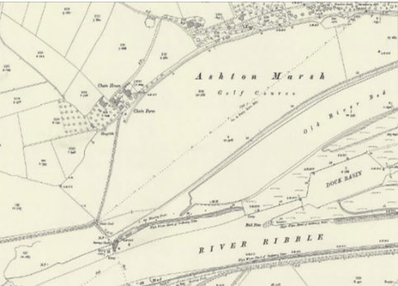
In this unit of work we will be covering: Communication, enquiry and chronology.
“Sticky Knowledge”

Anglo-Saxons |  | The main group of people living in Britain when the Vikings invaded.
Danelaw |  | The area in Britain that the Danish Vikings ruled over.
Longship |  | A Viking ship used for fighting and carrying out raids.
Monastery |  | A place where people who have dedicated their lives to religion, such as monks or nuns live.
Pagan |  | A person who believes I many gods.
Chieftain |  | The leader of a village or small group of people in Danelaw.
Rune |  | A letter from the alphabet used y Vikings.
Thatched |  | A roof covered in straw.
Trader |  | A person who sells goods.
“Sticky Knowledge”
Key Vocabulary
Diagrams

Diagrams


