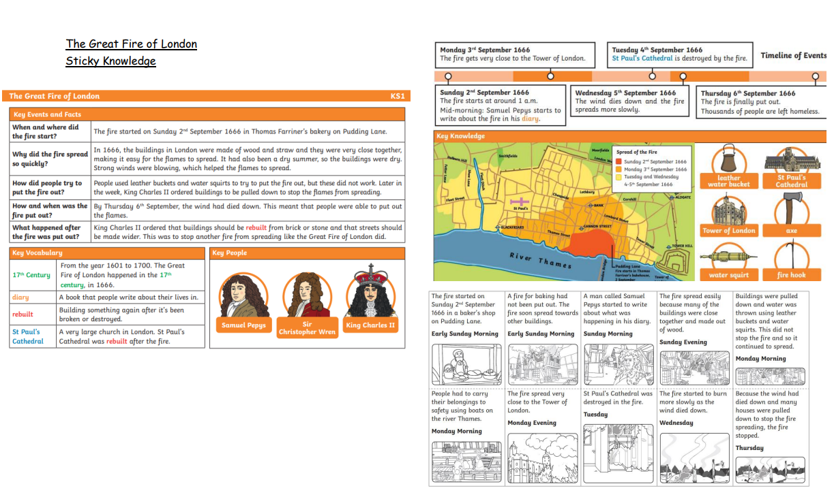
Key Vocabulary
17th Century, Diary, Rebuilt, St Paul’s Cathedral, Fire, Samuel Pepys, Pudding Lane, Baker, Smoke, River Thames, The Great Fire of London, King Charles 2nd, Wood, Straw
Sticky Knowledge
When and where the fire started? Why did the fire spread so quickly? How did people try to put the fire out? How and when was the fire put out? What happened after the fire was put out?
The focus of this unit is…
events beyond living memory that are significant nationally or globally.

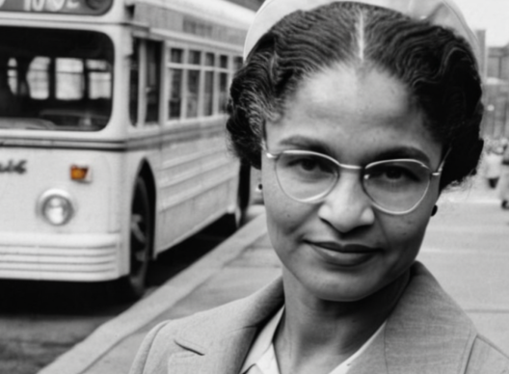
Significant Events throughout History - Rosa Parks and Martin Luther King
The focus of this unit is…
Events beyond living memory which are significant nationally or globally. The lives of significant individuals in the past who have contributed to national and international achievements. Make simple observations about different people, events, beliefs and communities.
Key Vocabulary
Campaign, Segregation, Race, Civil Rights, Racism, Prejudice, Discrimination, Protest.
Sticky Knowledge
Rosa Parks and Martin Luther King fought for the rights of black people in the USA. Everyone throughout history should be shown equality (status, rights and opportunities.
How did Rosa Parks and Martin Luther King have an impact on the world regarding prejudice and discrimination?

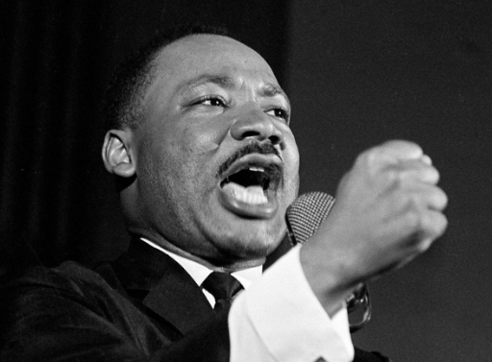

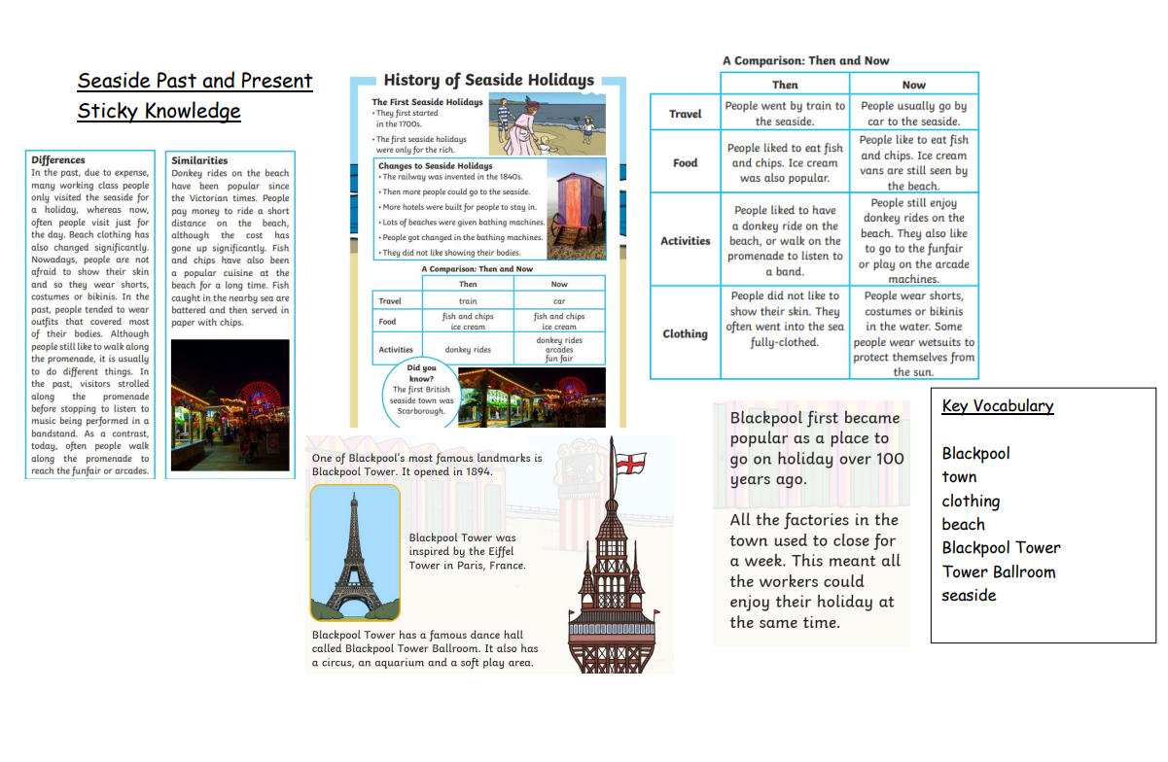

The focus of this unit is…
Significant historical events, people and places in the pupils’ own locality. Changes within living memory (including aspects of national life where appropriate)
Sticky Knowledge
How has Blackpool changed throughout its history? Why do/did people visit Blackpool Seaside? How has the clothing/activities/food and travel changed then and now? Why did/do people want to visit Blackpool for Seaside holidays? Blackpool tower is an important landmark for Blackpool. Blackpool tower ballroom is an important landmark for Blackpool.

