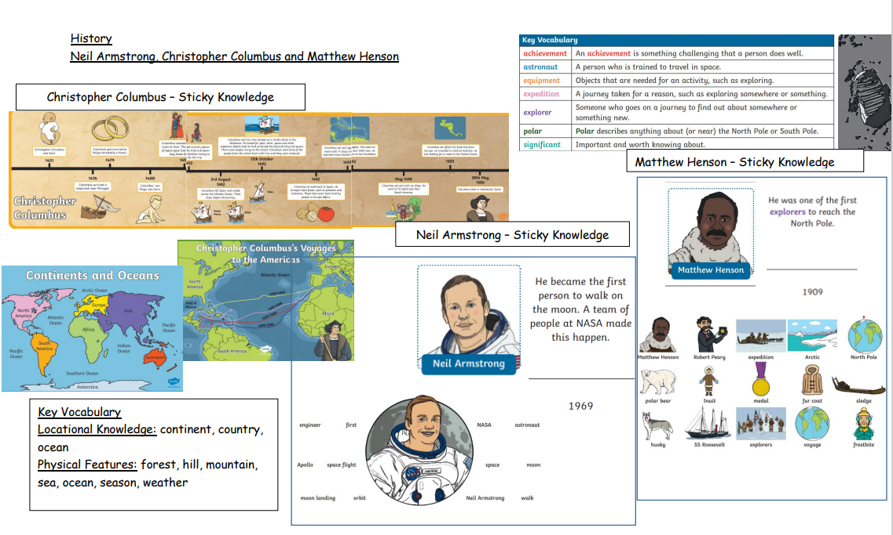
Key Vocabulary
Achievement, Astronaut, Equipment, Expedition, Polar, Significant, Continent, Country, Ocean, Season, Mountain, Weather.
Sticky Knowledge
To use timelines/chronology to support the events of significant people throughout history. What national and international achievements have Neil Armstrong, Christopher Columbus and Matthew Henson contributed to? Where did Neil Armstrong, Christopher Columbus and Matthew Henson explore? How was life different between Neil Armstrong, Christopher Columbus and Matthew Henson’s life?

The focus of this unit is…
the lives of significant individuals in the past who have contributed to national and international achievements. Also, to compare aspects of life in different periods.

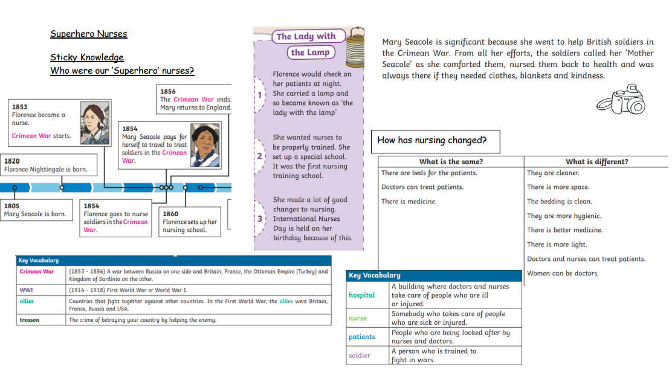

Key Vocabulary
Crimean War First World War (WW1) Allies Treason Hospital Nurse Patients Soldier
Sticky Knowledge
What jobs did Mary Seacole and Florence Nightingale have? How do nurses help us? How is life different in the past compared to the present day? What would life be like as a solider at war?
How have hospitals changed because of the events in the past?
The focus of this unit is…
events beyond living memory that are significant nationally or globally and the lives of significant individuals in the past.
The lives of significant individuals in the past who have contributed to national and international achievements. Significant historical events, people and places in the pupils’ own locality

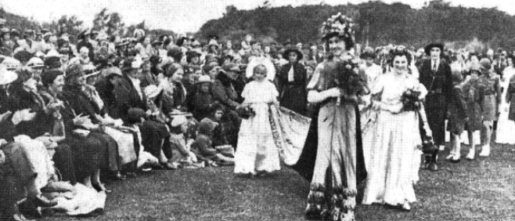
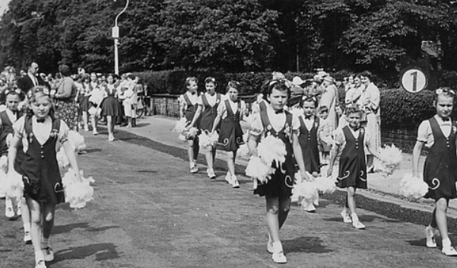
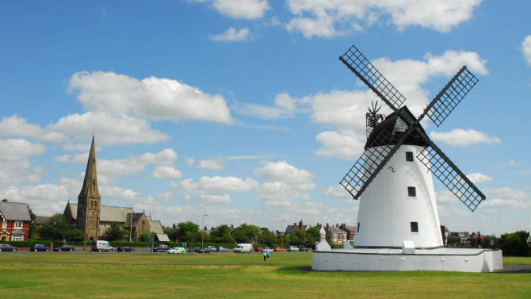
Changes within living memory – Our local area (Lytham)
Key Vocabulary
Rural, Seaside town, Amalgamated, Victorian, Era, Industrialists, retirement.
Sticky Knowledge
How has Lytham changed over the last 100 years? Why did Lytham have to grow from a small rural area to a more developed seaside town? To explore why Lytham and St. Anne’s amalgamated in 1922. How did the Victorian era have an impact on Lytham? How did the industrialists have an impact upon Lytham as a seaside town?
The focus of this unit is…
Changes within living memory (including aspects of national life where appropriate)

