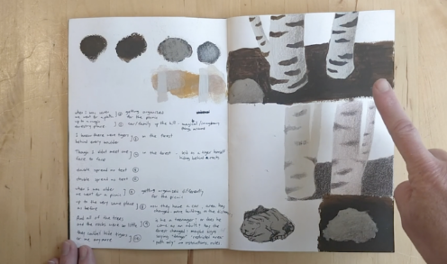
Sculpture – Telling stories through drawing and making
- Rosie Hurley, Inbal Leitner, Roald Dahl, Quentin Blake

Materials Soft B pencils, coloured pencils, oil/chalk pastels, handwriting pens, A3 or A2 cartridge paper.
Option 1: Modroc or Clay Characters – Newspaper, masking tape, modroc, air dry clay, acrylic or ready mixed paint, brushes, trays.
Option 2: Plasticine Characters – A3 cartridge paper, modelling plasticine, constructed materials, corrugated card circles.
Option 2: Flying MinPin Characters – Air dry clay, wire, A4 or A3 cartridge paper, tissue paper, feathers, PVA glue.
Option 3: James and the Giant Peach Literacy Garden – assorted construction materials.

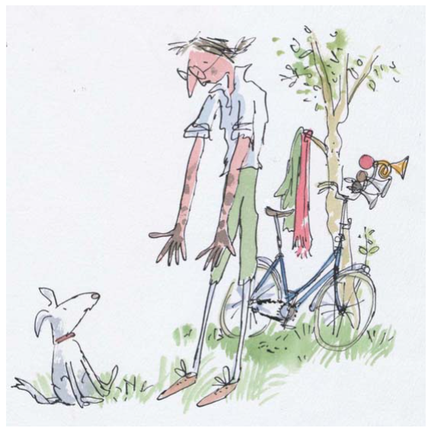
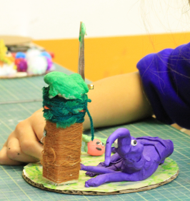
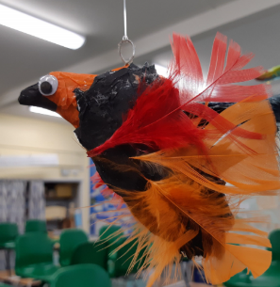
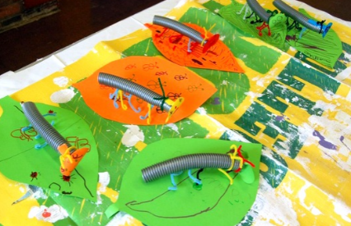
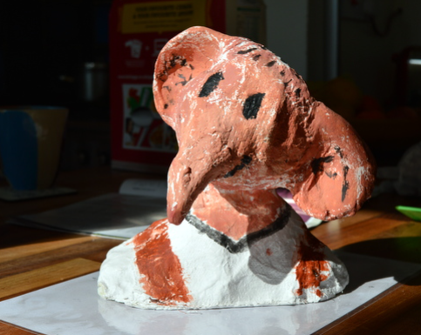
Key Vocabulary
Sketchbooks, Brainstorm, Explore, Experiment, Test, Try Out, Line, Shape, Wash, Layer, Pen, Watercolour, Exaggerate, Gesture, Sculpture, Armature, Structure, Cover, Modroc, Clay, Construct, Model, Character, Personality, Present, Share, Reflect, Respond, Feedback, Photograph, Lighting, Composition, Focus, Intention

Key Concepts:

That we can take inspiration from other art forms such as film and literature and make work in 3 dimensions in response.

That through making work in another medium we can make the work our own, re-interpreting and re-inventing.

That we can explore character, narrative and context and create objects (sculptures) which convey these qualities through their form, texture, material, construction and colour.

Drawing Lines – Leo Gestel
Teacher Feedback:

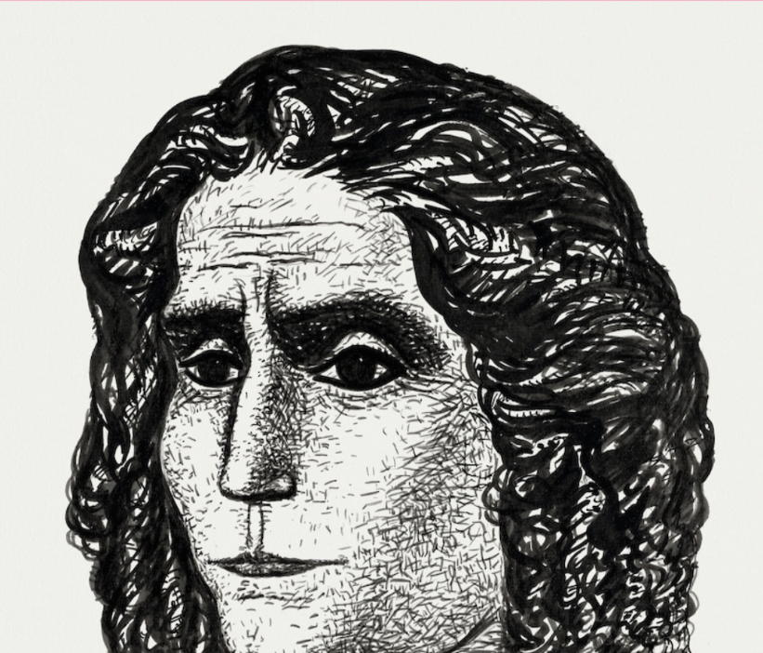
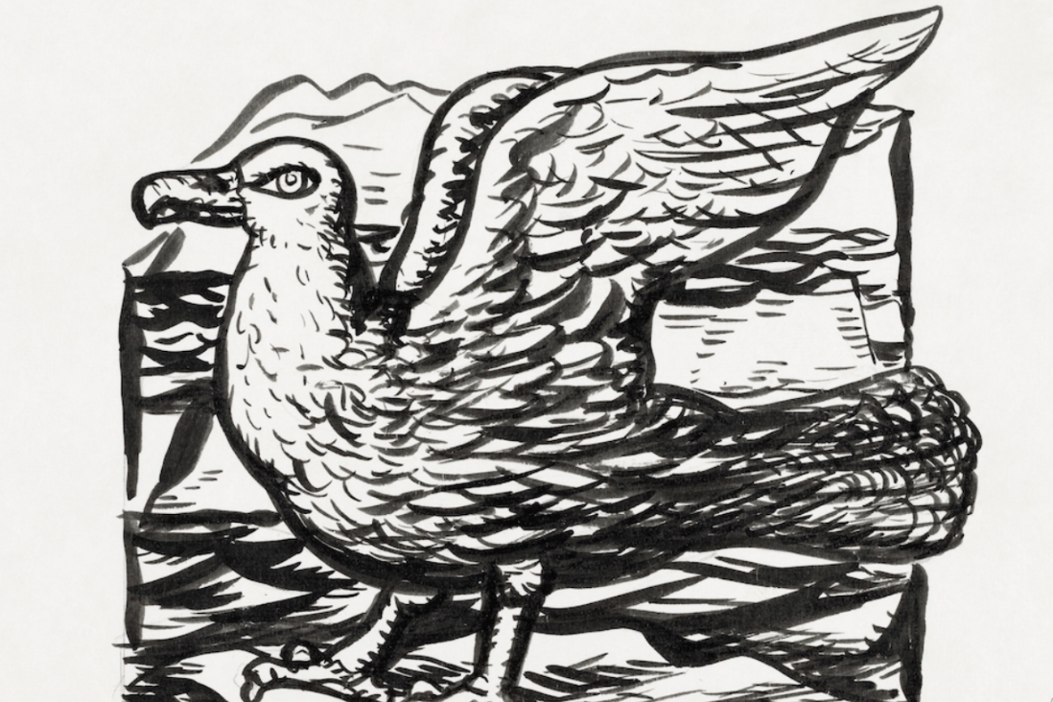
Drawing Lines – Leo Gestel
Drawing and Collage – Flora and Fauna - Eric Carle
Teacher Feedback:
Key Vocabulary
depth, tone, weight, line, thick, thin, pressure, tool, delicate, bold, power, intention, sketchbooks, test, try out, exaggerate

Key Concepts
Line weight refers to the thickness or thinness of a line. The weight of a line can be altered by applying different amounts of pressure to a drawing tool and by changing the drawing media.

Depth, tone, character and atmosphere can be achieved by exploring a variety of weighted lines in drawings.

When we look at the lines in drawings we may get an impression of what the artist was experiencing or what they are trying to communicate through their drawing. For example, thinner lines can create a delicate peaceful atmosphere whereas thicker bold drawings can evoke a sense of power and authority.

Key Vocabulary
Flora, Fauna, Line, Shape, Colour, tones, hues, tints, Observe, Graphite, Handwriting Pen, Collage, Painted paper, cut, tear, arrange, play, composition, elements, Minibeast/Insect, Author, Illustrator, Present, Reflect, Share, Discuss

Key Concepts:

That artists can be inspired by the flora and fauna around them.

That we can use careful looking to help our drawing, and use drawing to help looking.

That we can use a variety of materials to make images, and that the images we make can become imaginative.

That we can create individual artwork, and that we can bring that artwork together to make a shared artwork.

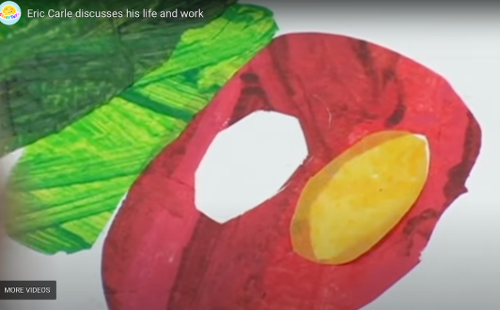
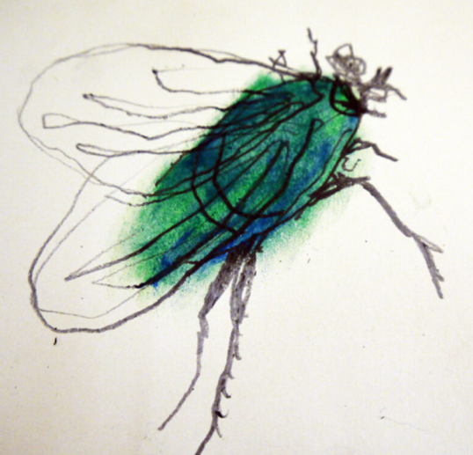
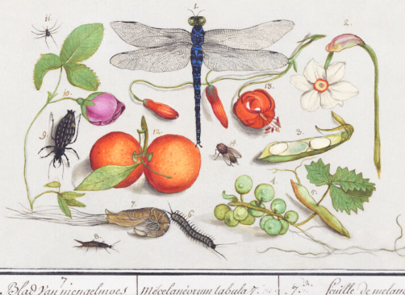

Materials

Sketchbooks, soft pencils, coloured pencils, oil/chalk pastels, handwriting pens, graphite, collage papers, A1 paper, water colour and/or ready mixed paint over sugar paper, brushes, scrap papers.

