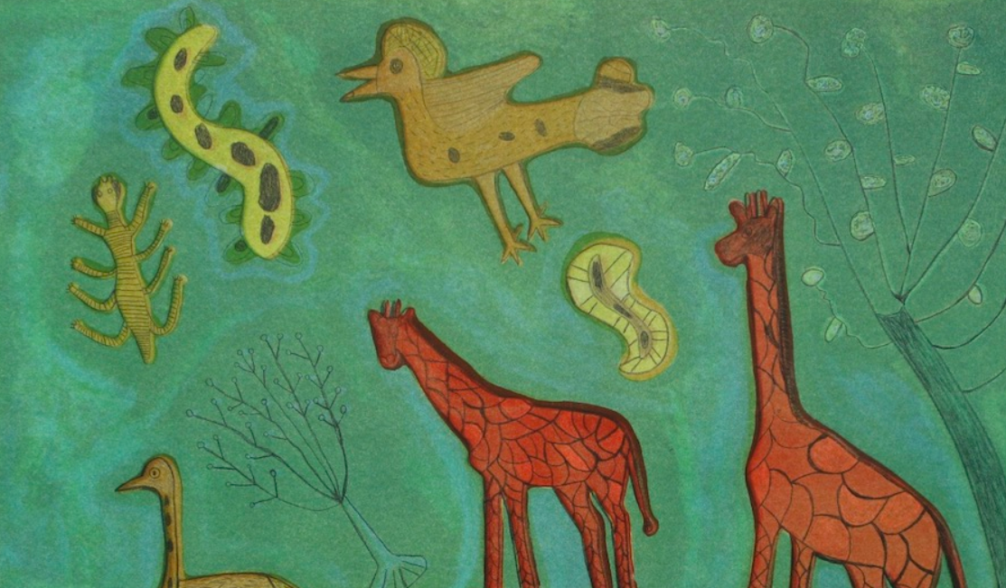
Xgaoc'o X'are
Printing from around the world
Teacher Feedback:
Key Vocabulary
Print, Press, Pressure, Paint Primary colours: Red, Yellow, Blue Shape, Line, Arrangement, Rubbing, Texture, Wax crayon, Pencil Crayon, Cut, Collage, Stick, Arrange Explore, Try, Test, Reflect, Artwork, Artist: Printmaker Relief print, Plasticine, Plate, Impression, Colour Mixing, Secondary Colours: Green, Orange, Purple Pattern, Sequence, Picture, Image
Enquiry Question: How can we make prints using the things we find around us?

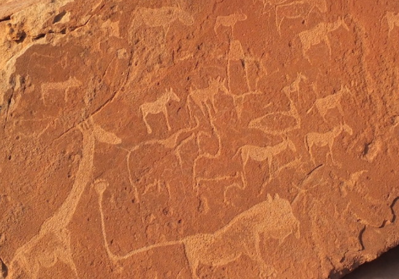

Describe what you see.
How does it make you feel?
Which words would you use to describe the whole piece?
How has the artists experience influenced this artwork?
What comparisons can you make between the artists work and the rock engravings?
Make a list of all the animals you often see in your environment.

Key Concepts:

When we make mono prints we use mark making to create one off prints.

When we make mono prints we create an impression of a drawing.

That we can generate playful narratives and inventions through drawing.

That we understand that using a range of marks will generate different effects when creating mono prints.

That we can create creative responses to different stimuli and make the work our own.

Background:
Xgaoc’o X’are grew up on a farm in the Ghanzi District in Western Botswana. He now makes mono Prints inspired by his knowledge and love of the Kalahari.

For Xgaoc’o, art gives him the opportunity to put the ideas in his head on a canvas in beautiful naive forms and playful colours. His work is informed by a childhood spent working on farms and hunting with his father and brother for food.

His work is a reflection of his love of the Kalahari Desert and captures the essence of the rock art created centuries ago by his ancestors in Twyfelfontein. The oldest engravings are thought to be as old as 10,000 years.

He signs his work in his Naro name Qhaqhoo.

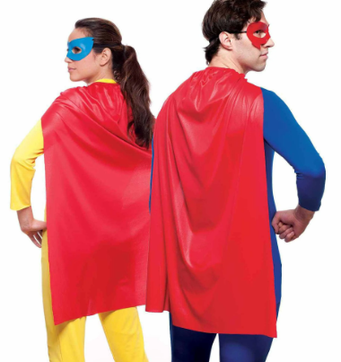
Painting and embroidery (Alice Kettle)
Textiles

Alice Kettle

Alice Kettle is a contemporary textile/fibre artist based in the UK. Alice originally trained as a painter and will often begin her work with a painted background which she then embroiders on. Her large scale work is composed of individual tiny stitches, which combine to form great swathes of colour, painterly backgrounds incorporating rich hues.

Teacher Feedback:
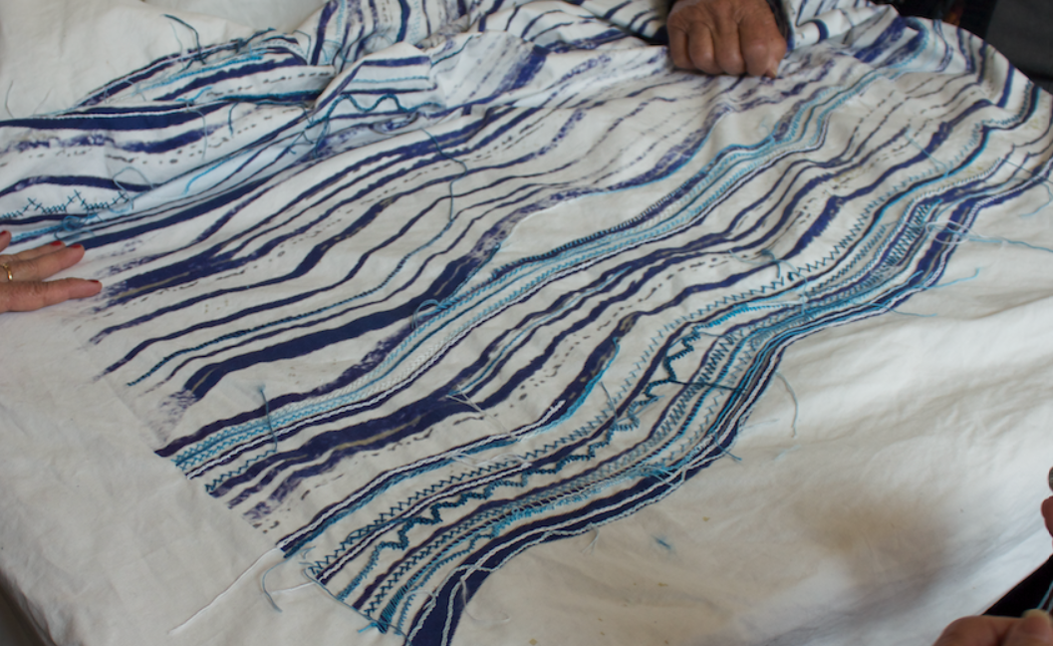
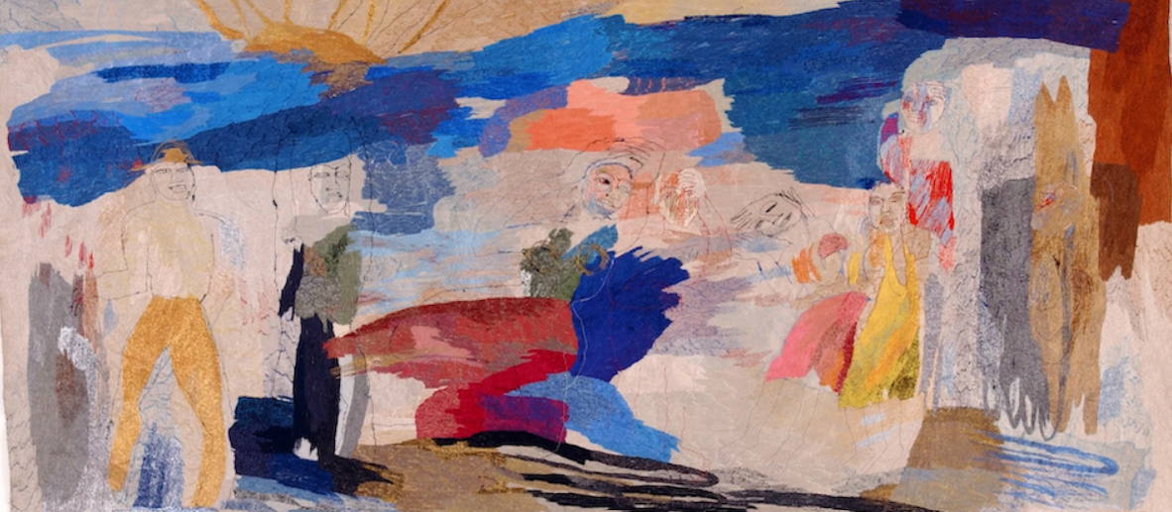
Key Vocabulary
Fabric, pattern, print, design, reflect, paint, embroidery, colour, stitch, fibre

How does the work make you feel?

How do you think that collaboration benefitted the community and the artist?

What connections can you see to the sea in these works?

How does scale impact the viewers experience of the work?

Teacher Feedback:
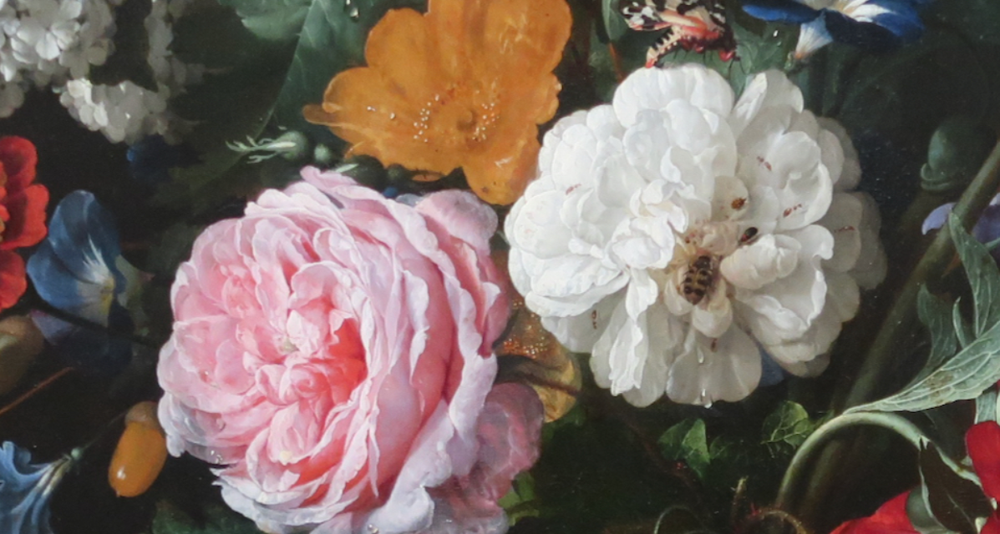
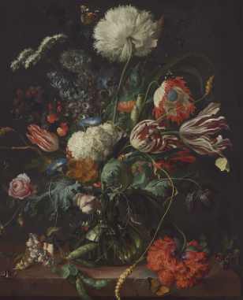
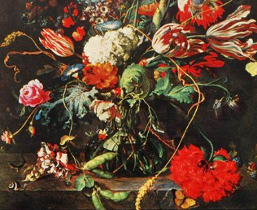
Still Life Observational Drawing and Painting – ‘Flowers in a Glass Vase’ - Jan Davidsz de Heem
Enquiry Question: How can we become open, curious, explorers of the world, and use what we find to inspire us to make art?
Key Vocabulary
Explore, Collect, ReSee, Imagine, Curious, Present, Re-present, arrange, composition Photograph, Focus, Light, Shade, Observational Drawing, Close study, Draw slowly, Intention, Pressure, Line, Mark, Page, Sense of Touch

Key Concepts:

That artists explore the world, seeing things around them in new ways, and bring things back to their studios to help them make art.

That we can go into our own environments, even when they are very familiar to us, and learn to see with fresh eyes and curiosity.

That we can use the things we find to draw from, using close observational looking.

That we can explore and use art materials, be inventive with how we use them, taking creative risks and enjoying accidents as well as planned successes.

We can use the shape of the page, and the way we arrange elements on the page, to create compositions which we like.

How would you describe the mood of this painting?

How have the colours impacted the mood?

How does the painting make you feel?

ass Vase’ by the Dutch painter, Jan Davidsz de Heem

ass Vase’ by the Dutch painter, Jan Davidsz de Heem

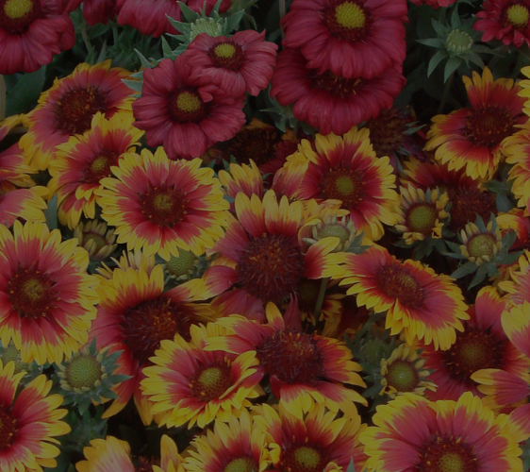
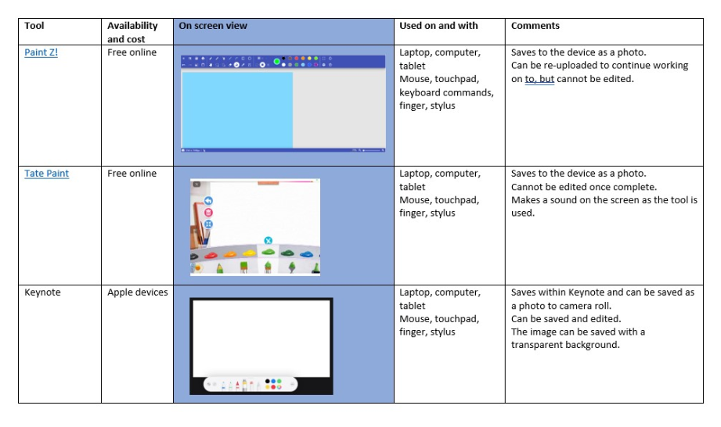
Digital Art/ Media – Plants
Teacher Feedback:

- Exploring overlap and transparency
- Shape and fill
- Creating layers
- Cutting, rotating and moving sections of the painting
- Using pattern as paint

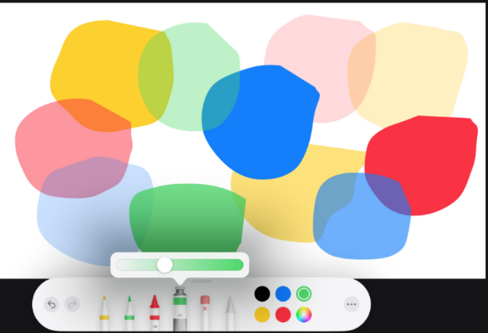

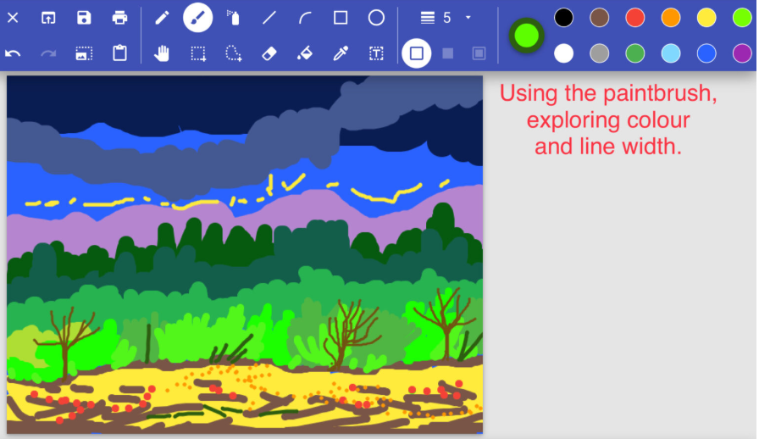
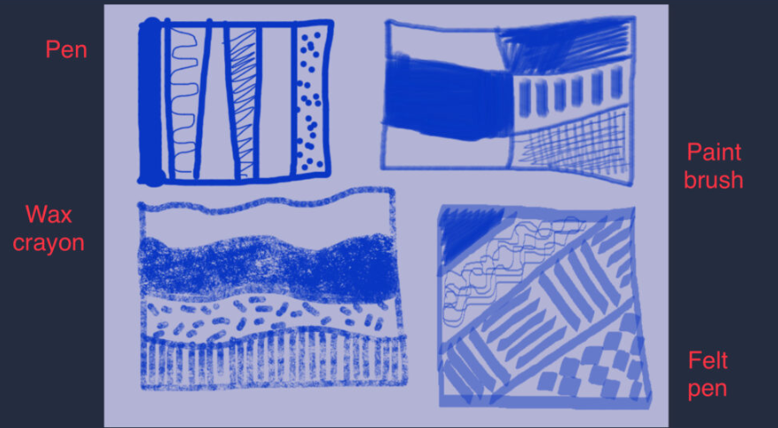

Key Vocabulary:
Paint, technology, ipad, layer, colour, explore, line, width, shape, brush, tool, cut, rotate, pattern, fill, shape, overlap

