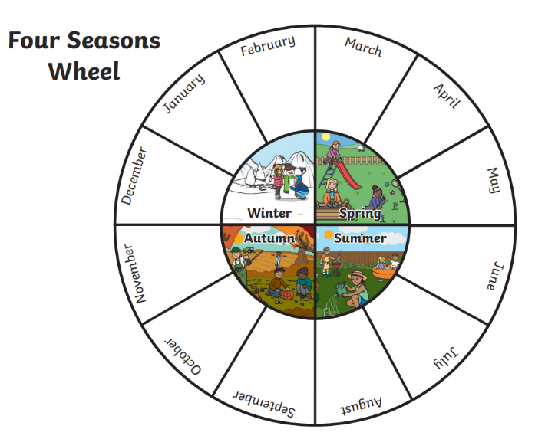
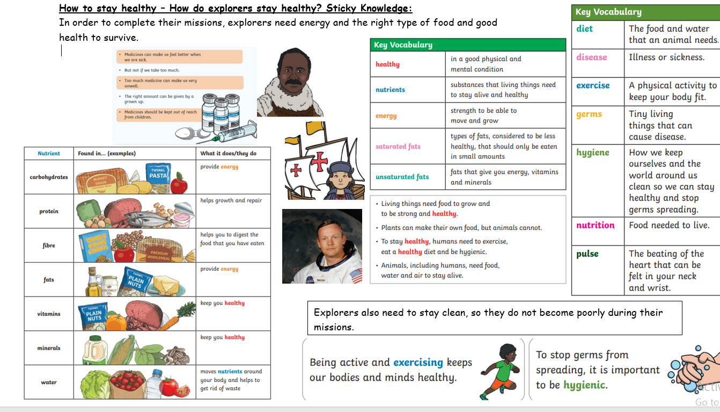
Key Learning:
Seasonal Changes – Light and Astronomy (Link to Explorers)
Observe and describe changes across the four seasons.
Observe and describe weather associated with the seasons and how day length and temperature varies
Health – How to grow and stay healthy
Notice that humans have offspring which grow into adults.
Find out about and describe the basic needs of humans, for survival (water, food and air).
Describe the importance for humans of exercise, eating the right amounts of different types of food, and hygiene.
Medicines can be useful when we are ill.
Medicines can be harmful if not used properly.

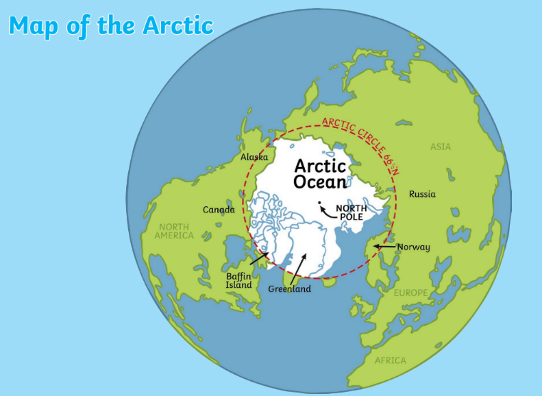
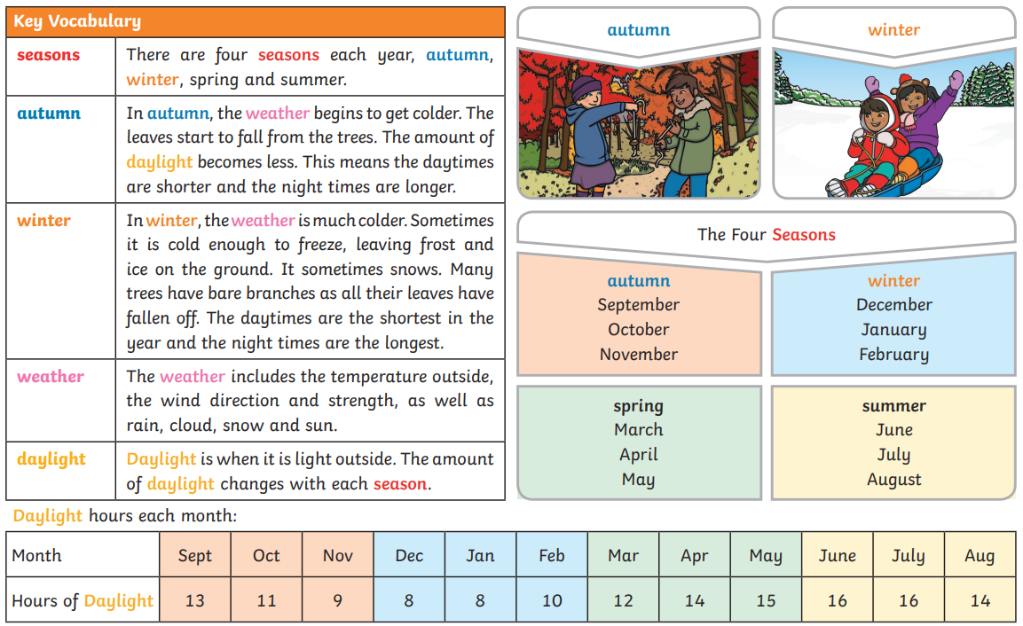

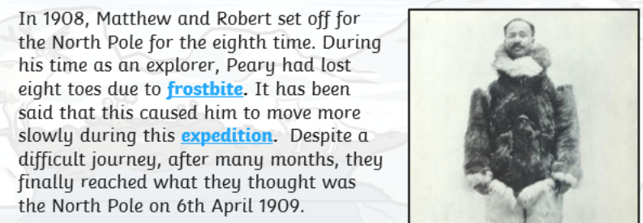
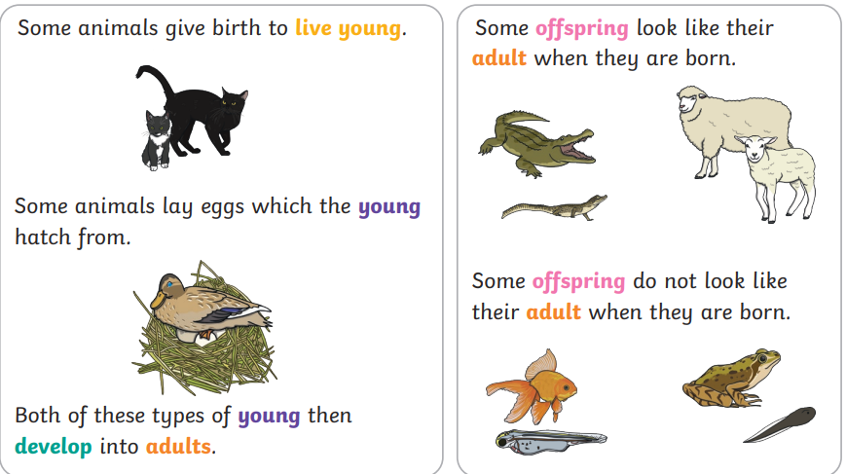
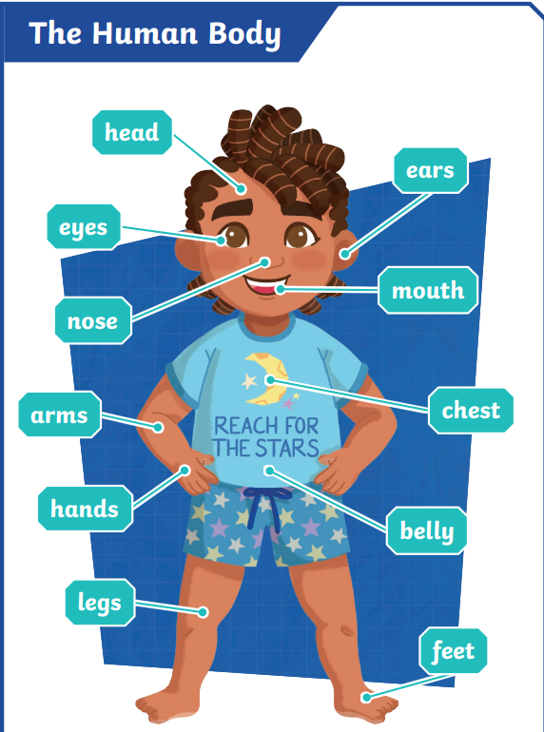
Key Learning
Animals – Humans
Identify, name, draw and label the basic parts of the human body and say which part of the body is associated with each sense.
Recognise that humans are animals.
Compare and describe differences in their own features (eye, hair, skin colour, etc.).
Recognise that humans have many similarities.
Animal Survival and Growth
Notice that animals have offspring which grow into adults.
Find out about and describe the basic needs of
animals for survival (water, food and air).
Superheroes – Sticky Knowledge
Animals – Humans
Animal Survival and Growth

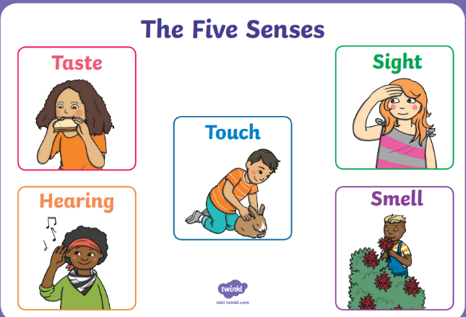
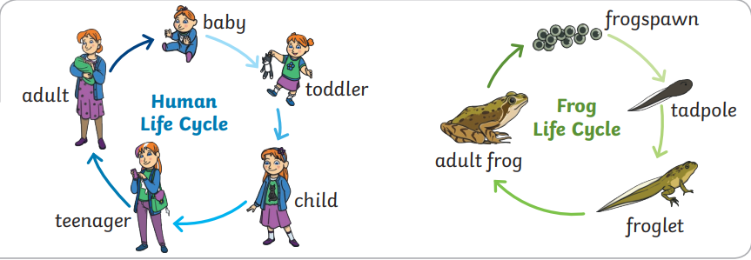
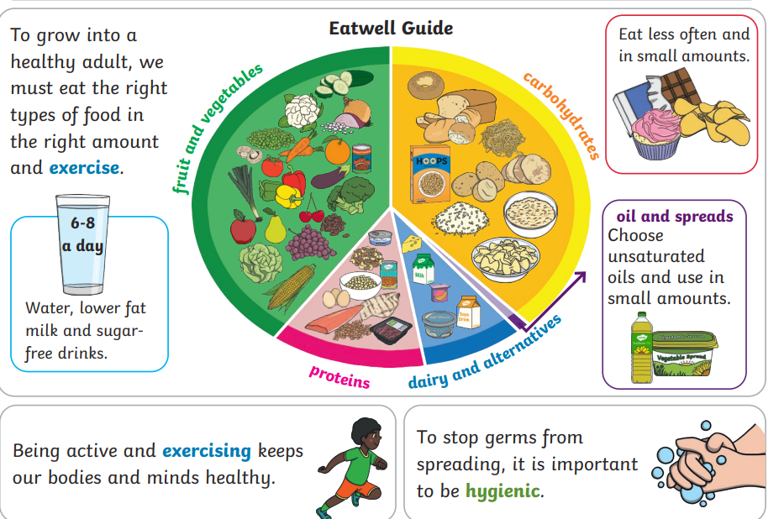
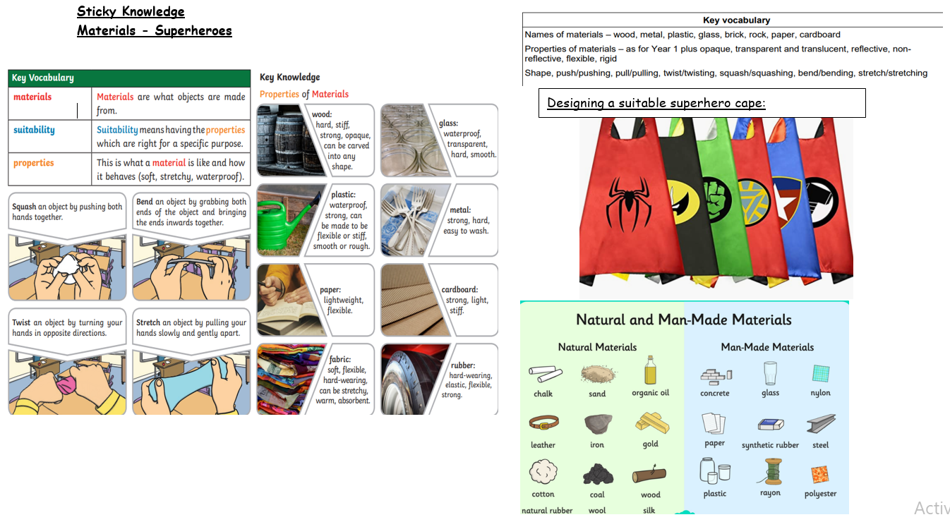
Key Vocabulary
offspring, growth, teenager, adult, toddler, live young, active, exercise, germs, hygienic, taste, touch, sight,
hearing, smell

Key Learning:
Uses of Materials
Identify and compare the suitability of a variety of everyday materials, including wood, metal, plastic,
glass, brick, water, rock, paper and cardboard for particular uses
Find out how the shapes of solid objects made from some materials can be changed by squashing, bending, twisting and stretching (applying a force)
Some materials can be found naturally; others have to be made

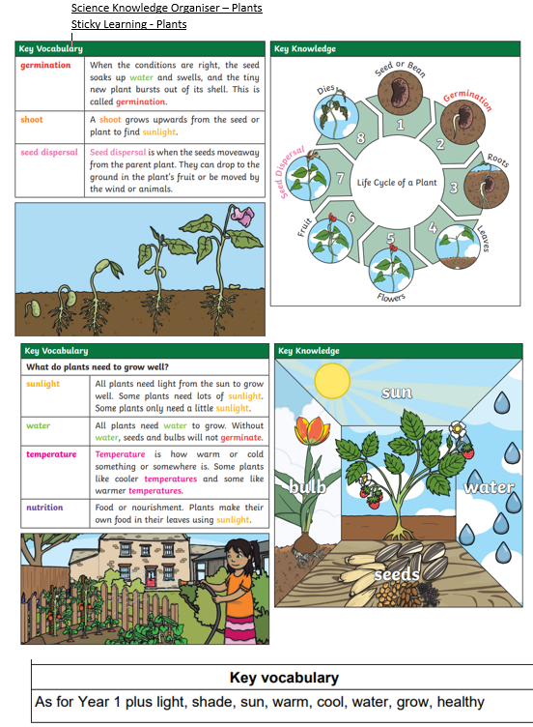
Plants (Common Names and Basic Structure)
Identify and name a variety of common wild and garden plants, including deciduous and evergreen trees.
Identify and describe the basic structure of a variety of common flowering plants, including trees (at least: flower, leaf, root, stem, trunk, seed, branch and petal).
Plant Growth
Observe and describe how seeds and bulbs grow into mature plants
Find out and describe how plants need water, light and a suitable temperature to grow and stay healthy (and how changing these affects the plant)
Plants are living and eventually die
Environment: Living things and habitats.
Explore and compare the differences between things that are living, dead, and things that have never been alive.
Identify that most living things live in habitats to which they are suited and describe how different habitats provide for the basic needs of different kinds of animals and plants, and how they depend on each other.
Identify and name a variety of plants and animals in their habitats, including micro-habitats.
Describe how animals obtain their food from plants and other animals, using the idea of a simple food chain, and identify and name different sources of food.
Different kinds of plants and animals live in different kinds of places.
There are different kinds of habitat near school which need to be cared for
Habitats provide the preferred conditions for the animals/plants that live there (compare local habitats and less familiar examples).
Observe living things in their habitats during different seasonal changes


