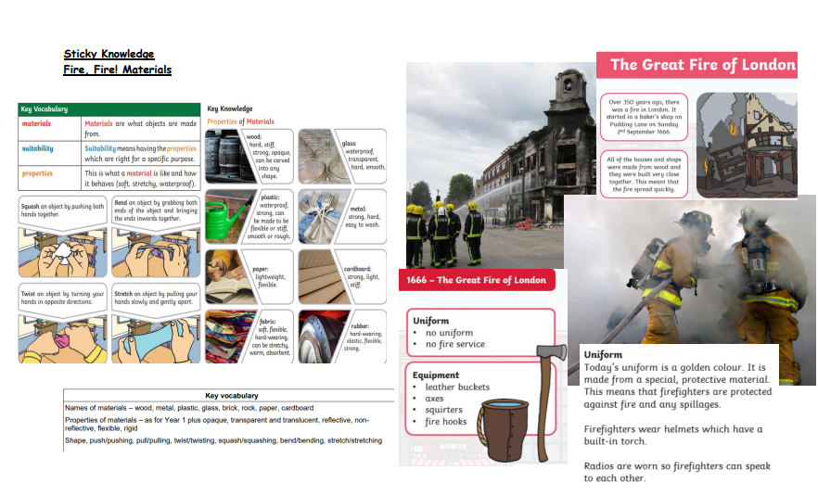
Key Learning
Material Properties (Protective Clothing)
Distinguish between an object and the material from which it is made.
Identify and name a variety of everyday materials, including wood, plastic, glass, metal, water, rock, brick, paper and cardboard.
Describe the simple physical properties of a variety of everyday materials.
Compare and group together a variety of everyday materials on the basis of their simple physical properties.
Uses of Materials
Identify and compare the suitability of a variety of everyday materials, including wood, metal, plastic,
glass, brick, water, rock, paper and cardboard for particular uses
Find out how the shapes of solid objects made from some materials can be changed by squashing,
bending, twisting and stretching (applying a force)
Some materials can be found naturally; others have to be made

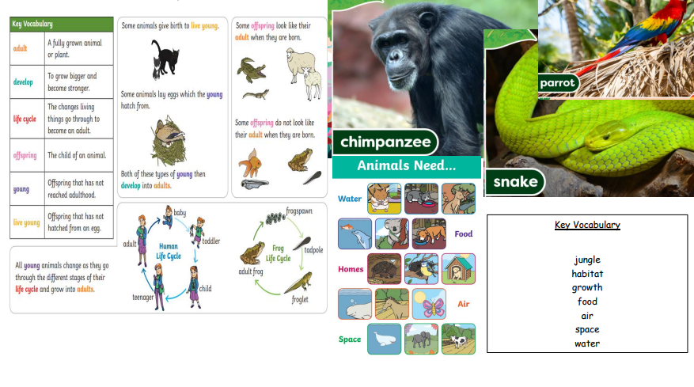
Key Learning
Survival and Growth:
Notice that animals have offspring which grow into adults.
Find out about and describe the basic needs of animals for survival (water, food and air).
Animals – Other Animals
Identify and name a variety of common animals including some fish, some amphibians, some reptiles, some birds and some mammals.
Identify and name a variety of common animals that are carnivores, herbivores and omnivores (i.e. according to what they eat)
Describe and compare the structure of a variety of common animals (fish, amphibians, reptiles, birds and mammals, and including pets).
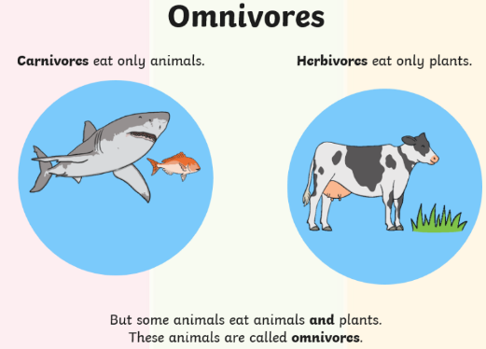
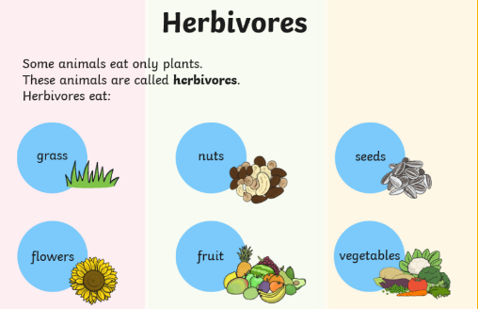
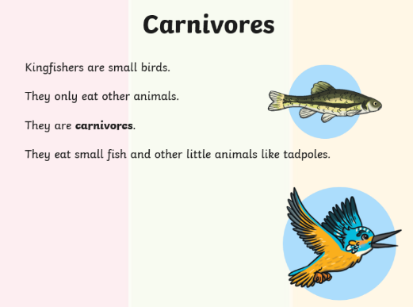

Sticky Learning
Animal Survival and Growth
Other Animals

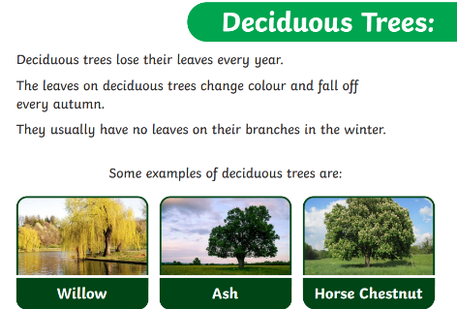
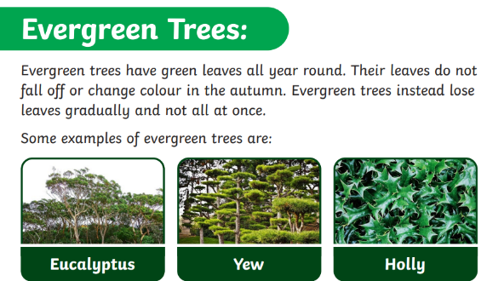
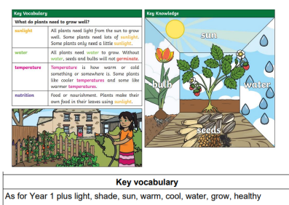
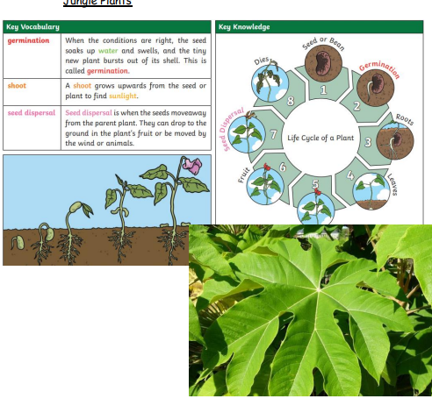
Plants (Common Names/Basic Structures)
Plant Growth
Key Learning
Plants (Common Names and Basic Structure)
Identify and name a variety of common wild and garden plants, including deciduous and evergreen trees.
Identify and describe the basic structure of a variety of common flowering plants, including trees (at least: flower, leaf, root, stem, trunk, seed, branch and petal).
Plant Growth
Observe and describe how seeds and bulbs grow into mature plants
Find out and describe how plants need water, light and a suitable temperature to grow and stay healthy (and how changing these affects the plant)
Plants are living and eventually die

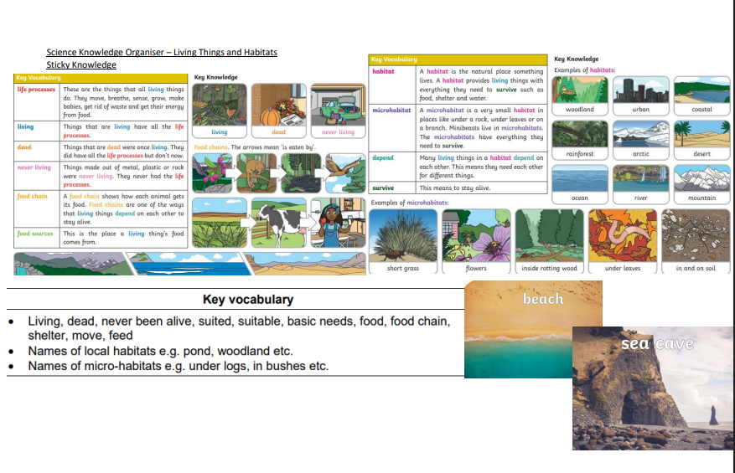
Key Learning:
Environment:
Living things and their habitats (Blackpool – Beach Habitat focus)
Explore and compare the differences between things that are living, dead, and things
that have never been alive.
Identify that most living things live in habitats to which they are suited and describe how
different habitats provide for the basic needs of different kinds of animals and plants,
and how they depend on each other.
Identify and name a variety of plants and animals in their habitats, including micro-habitats.
Describe how animals obtain their food from plants and other animals, using the idea of a simple food chain, and identify and name different sources of food.
Different kinds of plants and animals live in different kinds of places.
There are different kinds of habitat near school which need to be cared for
Habitats provide the preferred conditions for the animals/plants that live there (compare local habitats and less familiar examples).
Observe living things in their habitats during different seasonal changes

